Installation of Cucumber

Pre-requisites to write Selenium Automation Test-

- Set Up Java on System
- Set Up Eclipse IDE or any other IDE
- Set Up Maven
- Create a new Maven Project
- Create a ‘resources’ folder for Cucumber Tests
- Add Selenium to Project
- Add Maven Compiler Plugin

Step 1: Set Up Java
Selenium & Cucumber requires a version of Java to be on the system we are running our tests from. Selenium Java bindings require only the Java Runtime Environment (JRE), but we’ll be fine if we have either the Java Development Kit (JDK) or JRE installed

Step 2: Set up Eclipse IDE

Eclipse is one of several widely popular editors for Java. It’s an open source project maintained by the Eclipse Foundation, and has a huge marketplace of add-ons, tools, and customisation.

Step 3: Set up MAVEN

Apache Maven provides support for managing the full lifecycle of a test project.

- Maven is used to define project structure, dependencies, build, and test management.

- Using pom.xml(Maven) you can configure dependencies needed for building testing and running code.

- Maven automatically downloads the necessary files from the repository while building the project.
Step 4: Create a new MAVEN Project
Detailed Maven installation links-

http://toolsqa.com/java/maven/create-new-maven-project-eclipse/

http://maven.apache.org/

Please make sure that you specify below values to Maven Archetype Parameters:

- Group ID : BDD (as per the need)
- Artifact ID: Cucumber Framework (as per the need)

Specimen-
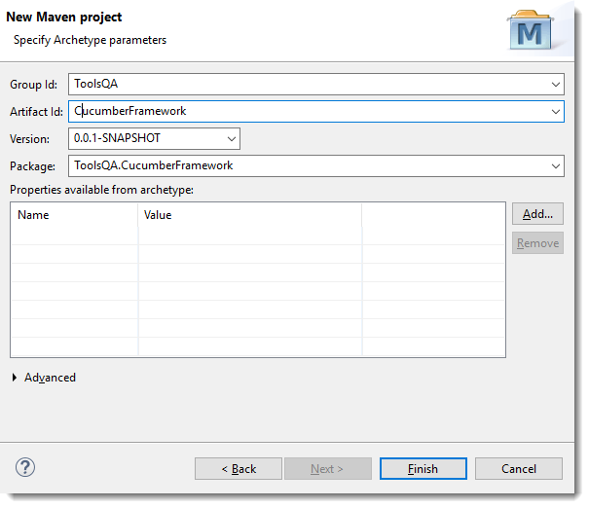
The newly created project will look like below-
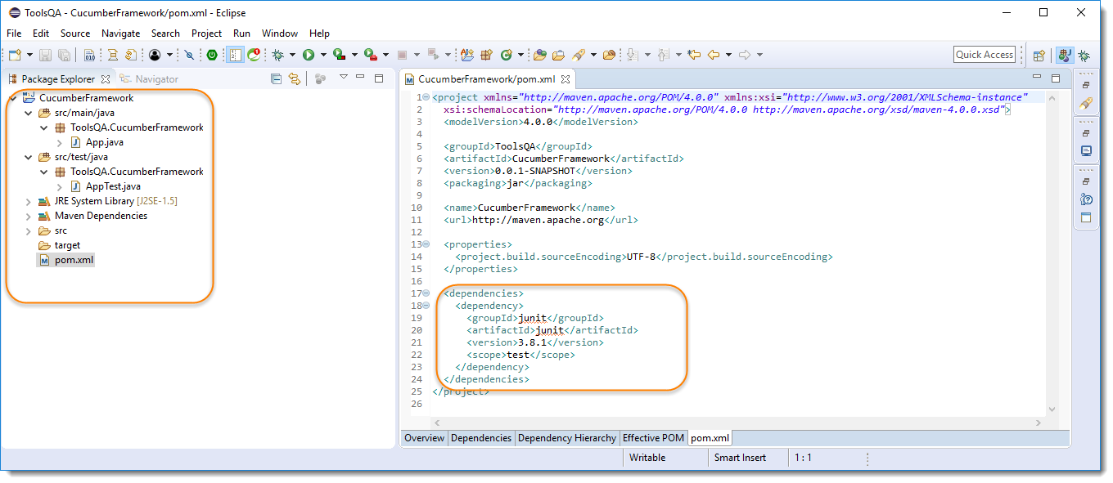

Step 5: Create a 'resources' folder

a. At first, we need to delete src/main/java and src/test/java folders and along with that App.java & AppTest.java file will also be deleted, which is just sample project files created by default by Maven.

b. Secondly we need to create a new resources folder under src/test/. As a standard we keep Cucumber feature files in resources folder.
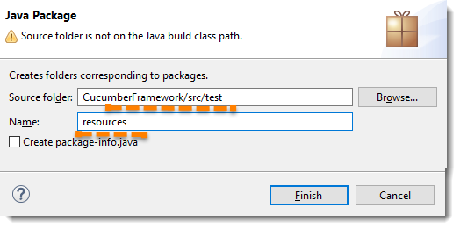

Right click on the root project and select Maven >> Update Project..

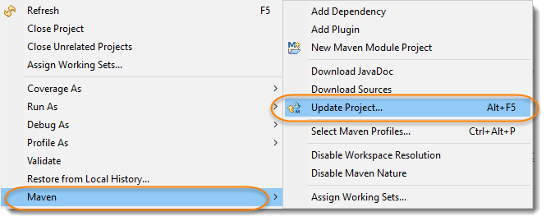
Note: Any changes in Maven POM, or any folder structure. Always update project using maven to reflect the latest changes. As maven make sure to download all the dependencies and plugins at the update.

Just check/tick the project and click on OK button.

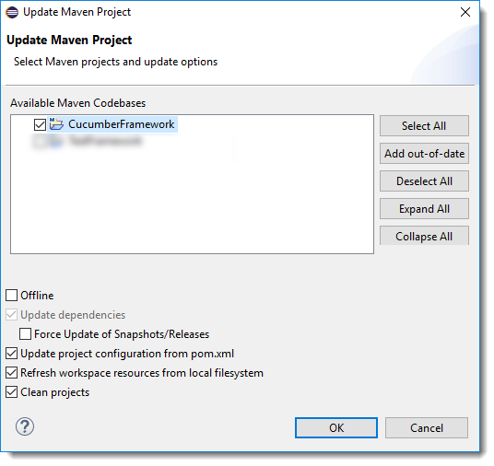

Step 6: Add the required dependencies in the pom.xml file

Refer site- https://mvnrepository.com/

The updated pom.xml file will look like this-

<project xmlns="http://maven.apache.org/POM/4.0.0" xmlns:xsi="http://www.w3.org/2001/XMLSchema-instance"
xsi:schemaLocation="http://maven.apache.org/POM/4.0.0 http://maven.apache.org/xsd/maven-4.0.0.xsd">
<modelVersion>4.0.0</modelVersion>

<groupId>SoumyaProject</groupId>
<artifactId>SoumyaMavenProject</artifactId>
<version>0.0.1-SNAPSHOT</version>
<packaging>jar</packaging>

<name>SoumyaMavenProject</name>
<url>http://maven.apache.org</url>

<properties>
<project.build.sourceEncoding>UTF-8</project.build.sourceEncoding>
</properties>

<dependencies>
<!-- https://mvnrepository.com/artifact/org.seleniumhq.selenium/selenium-java -->
<dependency>
<groupId>org.seleniumhq.selenium</groupId>
<artifactId>selenium-java</artifactId>
<version>3.9.1</version>
</dependency>

<!-- https://mvnrepository.com/artifact/org.apache.maven.plugins/maven-compiler-plugin -->
<dependency>
<groupId>org.apache.maven.plugins</groupId>
<artifactId>maven-compiler-plugin</artifactId>
<version>3.7.0</version>
</dependency>
<!-- https://mvnrepository.com/artifact/org.apache.maven.plugins/maven-surefire-plugin -->
<dependency>
<groupId>org.apache.maven.plugins</groupId>
<artifactId>maven-surefire-plugin</artifactId>
<version>2.20.1</version>
</dependency>
<!-- https://mvnrepository.com/artifact/junit/junit -->
<dependency>
<groupId>junit</groupId>
<artifactId>junit</artifactId>
<version>4.12</version>
<scope>test</scope>
</dependency>

Next- We need to add all the Cucumber dependencies in the pom.xml file

